Designing a Restaurant Docket System: Proof of Concept
ITST7.400 special topic final report
Rhys bates BATESr2 2014000128
2025
Contents
1.0 - Executive Summary 3
2.0 - Introduction 4
3.0 - Literature Review 5
3.1 - The evolution of order management in hospitality 5
3.2 - Human-Computer interactions in High-Pressure environments 5
3.3 - Database and Automation in Kitchen Systems 5
3.4 - The impact of System Design on Chef Wellbeing 6
3.5 - The role of UI design in positive user experience/interactions 6
3.6 Summary of Literature Review 6
4.0 - Methodology 7
4.1 - Research Approach 7
4.2 - Feasibility Analysis 7
4.3 – Interviews 7
4.4 - User Testing 8
4.5 - Development Process 8
5.0 - Findings and Discussion 9
5.1 - System Overview 9
5.2 - Development Timeline 9
5.3 - What worked well 9
5.4 - What did not work / limitations 9
5.5 - User Testing Insights 10
5.6 – Future Refinements Based on Feedback 10
6.0 - Conclusion and Recommendations 10
6.1 - Summary of Key Findings 10
6.2 - Recommendations for future work 10
6.3 - Reflections on personal learning 11
6.4 - Limitations and next steps 11
7.0 – References 12
8.0 – Bibliography 12
9.0 - Appendices 13
9.1 - Scope Change Documents 13
9.2 - Interview Transcripts 15
Interview 1 – “Chef A, Head chef/owner of Board and Boujee” 15
Interview 2 – “Chef B, Ex-head chef at Star Food Catering” 16
9.3 - User Testing Feedback 17
9.4 Feasibility analysis matrix 18
9.5 - Images of Developed UI 19
9.6 ERD 21
9.7 Data Dictionary 22
9.8 Images of created Database 23
9.9 Database creation 24
9.10 Python logic 24

- Executive Summary
Commercial kitchens operate under high-stress conditions, where effective communication, timing and organization are critical to a successful service. Traditional paper-based docket systems contribute to preventable performance issues by introducing clutter and cognitive overload to an already busy environment.
This project aims to address these issues by researching, designing, and prototyping a digital docket management system connected to Microsoft SQL database, with a Guizero-based user interface developed with basic python logic to achieve a lightweight system with usability in mind.
A mixed method approach was taken, including a literature review on cognitive load, workplace interface design, and adoption of technology in low-technology environments. This, combined with interviews and user testing of my product, has shaped the findings in this report.
Limitations from my proposed technology stack (and my own skills as a developer) has limited my ability to achieve a fully functional product, however I have produced a proof-of-concept product. (See images of product in appendix, see scope change documents in appendix)
Key findings from my literature review, interviews, and user testing indicate that a streamlined interface (focused only on essential features) can improve chef performance and increase the likelihood of technology adoption in low-technology kitchen environments.

2.0 - Introduction
Commercial kitchens represent a complex, time sensitive environment where communication, accuracy, organization, and time management directly impact service quality. During a “rush” (peak period of service), chefs manage several – up to hundreds of – orders at a time. Each order contains multiple components, including meals and modifications. Each order or “docket” requires accurate sequencing and coordination to ensure a smooth delivery of service. Traditional docket systems – usually paper slips hung on a rail above the pass – can easily become disorganized or deteriorate in a kitchen environment. Paper slips also require constant manual sorting. (Mallaury, 2025)
This project involved creating a proof of concept docket system, in which I have connected a GUI to a Microsoft SQL Server database. This allows for real time order creation and tracking. The initially proposed scope suggested that I would implement grouping systems along with highlighted alerts, however a scope change has been processed. These features were deemed “nice to have” and not necessary for a minimally viable product/proof of concept. (See appendix 9.1 for scope change documents.) The refined goal of this project was to create a proof-of-concept product that demonstrates ease of use. Research suggests that digital docket systems can improve overall kitchen functions while reducing errors presented by paper-based systems (Frank, 2025; Shepherd-Smith, 2025). Furthering this, digital tools designed with usability in mind reduce cognitive load and improve wellbeing in high pressure environments (Langote et al., 2024; Gada, 2025).
The scope of this project was to design and build a light weight docket management system, integrating database logic with a polished GUI, to demonstrate how digital solutions can support kitchen operations. By adopting a data driven approach to order management, modern kitchens will align with trends in modern industry, where automation and intelligent systems are supporting employees to become more efficient in the workplace. (Mucci, 2024).
This project reflects my own personal experience as a Chef. During my 8 years of professional cookery, I have personally encountered many of the problems that my designed system aimed to relieve. This has formed the motivation of this project. I have witnessed first-hand the disarray caused by paper docket systems and overlapping orders. Many coworkers (and myself) over the years have shown distress while managing competing priorities, and this has motivated my design approach; a lightweight system with usability in mind to support the wellbeing of chefs. Well structured, user focused systems ensure positive trends in employee wellbeing. (Gada, 2025).
The following report presents a literature review on docket systems and technology adoption in low technology environments, as well as the impact on good system design on employee wellbeing. It also outlines my chosen methodologies, discusses findings from interviews, feasibility analysis, prototype development, user testing, and concludes with recommendations for further research and development.
The initially proposed project scope has been altered during the development process of this project to ensure a quality outcome of this report. Features such as docket displays, docket grouping, and highlighting of important information has been indefinitely postponed to focus on a functional proof of concept product that has a GUI and can interact with a database. Despite the setback of not producing the initially proposed product, research shows that overly complex tools can hinder user adoption (Dunne, 2024) and that gradual implementation of a system is more effective in low technology environments (Tukkanen, 2025). The change in scope has ensured that the development of my prototype remains feasible, and that I can adhere to previously suggested deadlines. See appendix 9.1 for scope change documents.

3.0 - Literature Review

3.1 - The evolution of order management in hospitality
Order management in hospitality has evolved from traditionally hand-written paper slips to digital systems in modern kitchens. Early restaurants relied on paper slips to communicate orders between front of house and kitchen staff. These paper slips are prone to loss or damage during service, presenting opportunities for disarray during peak (“rush”) periods. The introduction of POS (point of sale) printers was the first major adoption of technology in kitchens, which allowed for faster and more legible docket creation (Frank, 2024). While this adoption improved some aspects of kitchen operations, the system still relies on paper slips that require constant manual organization.
Today, high-end restaurants are moving towards fully digital docket systems that integrate order entry, tracking, and display screens (Mallaury, 2025). As Shepherd-Smith (2025) notes, digital dockets eliminate visual clutter and prevents physical deterioration of paper dockets, while enabling more consistent record keeping. This transition reflects a shift in the industry towards digital solutions, integrating automation, aimed at reducing errors and improving efficiency across service stages (Shepherd-Smith, 2025).

3.2 - Human-Computer interactions in High-Pressure environments
In high pressure work environments, system design must consider cognitive load and environmental constraints. Research on Human-Computer Interaction (HCI) in healthcare – a setting with more emphasis on time management and user experience – shows that interface clarity and error prevention effect user performance and stress levels (Langote et al., 2024).
The same principles apply in kitchens, where chefs must process information quickly while multitasking to achieve a quality service. Well structured interfaces reduce cognitive load and allow workers to maintains focus under pressure (Gada, 2025). This project therefore adopted a simplified HCI approach, prioritising minimal navigation and instant GUI responses when creating dockets to support users in time-sensitive environments.

3.3 - Database and Automation in Kitchen Systems
A database plays a central role in automated docket systems. Databases allow structured data storage, querying via logic, and clear order data tracking. Automation logic within a database can help chefs by calculating preparation times for dockets, managing status updates/changes to dockets, and keeping a record of archived dockets without manually sorting through a pile of paper.
According to Mucci (2024), data-driven systems improve decision-making by providing fast access to desired/relevant information minimizing human error. Within the hospitality sector, database centred docket systems allow chefs to focus on quality production during service rather than managing paper slips.

3.4 - The impact of System Design on Chef Wellbeing
System design effects an employee’s overall performance as well as their well-being. A poorly designed interface can create opportunities for workplace stress, where intuitive systems support focus and efficiency, while reducing opportunities for stress and frustration (Gada, 2025).
In high-pressure environments like kitchens, small efficiencies will compound quickly, directly affecting employee morale and efficiency. The introduction of digital tools that are simple, reliable and easy to use can reduce the mental strain of managing multiple tasks at the same time (Langote et al., 2024). A system designed with the user in mind becomes a net-positive addition to a workplace rather than an additional burden.

3.5 - The role of UI design in positive user experience/interactions
User Interface (UI) design plays a central role in system adoption and long-term usability. Principles such as clarity, consistency, reliability, and immediate response are proven to enhance employee efficiency and user satisfaction (Lagote et al., 2024).
In high-intensity environments, visual clarity and colour coding help users to identify priorities quickly. This project initially aimed to incorporate these principles/features through colour-coded prompts and visual clarity, however as discussed in the introduction these features have been deemed out of scope (See appendix 9.1 for scope change documents).
The proof-of-concept product currently allows users to distinguish entrée, main and dessert items with headings above each section. When a user indicates that a modification is in fact due to an allergy, an exclamation mark is entered next to the modification. These simple features align with findings that intuitive design reduces cognitive load and encourages positive user experience (UX) (Gada, 2025; Tukkanen, 2025). In hospitality, where every second counds, a clear and responsive interface has a direct impact on both employee efficiency and well-being.

3.6 Summary of Literature Review
A theme has emerged throughout my sourced literature, where technology in hospitality must balance efficiency with usability. The progression from paper to digital systems (Frank, 2024; Mallaury, 2025) demonstrates real operational benefits. Successful adoption depends on the applications design and levels of complexity (Gada, 2025; Dunne, 2024). Automated solutions incorporating databases (Mucci, 2024) provides the technical foundation for more efficient kitchen operations, however user experience will ultimately determine successful adoption (and use) in high-pressure environments (Langote et al., 2024). These findings support my intention to create a lightweight, chef centred docket system that prioritizes clarity and chef well-being.

4.0 - Methodology

4.1 - Research Approach

Throughout this project I have adopted a mixed-method approach, combining qualitative insights and applied system design principles. The research began with a literature review on digital docket systems, HCI, and the adoption of technology in traditionally low-technology workplaces. I have then reviewed literature regarding the impact of UX and UI on employee wellbeing and efficiency. I have conduced two interviews (see Appendix 9.2 for interview transcripts) to identify pain-points in kitchens. The findings from my literature review formed the design of a proof of concept prototype, which was then evaluated via user-testing. (see Appendix 9.3 for user testing feedback.) This approach allowed for both literature based and practical insights to shape the development of this project.

4.2 - Feasibility Analysis

A feasibility analysis was conducted at the start of this project to determine whether it was more practical to build a custom docket management system or to adopt a purchased commercial product. Two popular systems – Square and Lightspeed – were compared against my custom built option.
Square is a tablet-based system that integrates with Square POS, offering digital ticket management and live updates for orders. Lightspeed performs similarly, however is designed for much larger organizations – Lightspeed is capable of integrating several work stations (including front of house and back of house operations). Lightspeed routes order details to screens at specific stations, meaning that employees only see relevant information on overhead screens. Both products offer stability and scalability.
The custom built system scored higher in my feasibility analysis in operational flexibility and cost effectiveness, as it would be tailored to address specific needs in individual kitchens. Purchased products such as Square and Lightspeed are not overly customizable, and have features that aren’t required in every kitchen. A custom build such as this project can be aimed towards improving chef well-being, by reducing cognitive load, highlighting particularly important information, and grouping dockets. As Dunne (2024) and Tukkanen (2025) state, new technology is more successfully adopted when it aligns with the requirements of the specific work environment. Building a lightweight prototype has also provided educational value, and demonstrated how custom IT solutions can bridge the gap left by commercial products.

4.3 – Interviews
Two interviews were conducted with two chefs to collect information on their experiences with existing docket systems. (See Appendix 9.2 for interview transcripts.) Both participants have reported frustration with paper docket systems, particularly with damage and loss of dockets. The information collected in these interviews has both confirmed the use-case for digital docket systems, as well as informed my decisions on GUI elements.

4.4 - User Testing
User testing was carried out with “Chef A”, who interacted with my prototype in an informal environment. While the user has reported general ease of use, the current state of the application does not have any real-world application in kitchen environments.
Due to my own personal limitations with understanding python logic, and limitations implied by my chosen technology stack, I have not yet been able to incorporate a way to show dockets created by the system.
Chef A has noted that the alert present on-screen is a welcomed addition, as it will draw a chef’s eyes to important information on a docket.
After explaining the features cut from the development process, such as colour coded highlights and docket grouping, Chef A has expressed that a product like this would be adopted in her kitchen – should ease of use and reliability be key aspects of the application.
(See Appendix 9.3 for user testing feedback.)

4.5 - Development Process
The development process followed an iterative design cycle. This involved a Microsoft SQL Server database creation, Guizero interface programming, and python logic programming.
The database for this application was designed using an entity relationship diagram (ERD) (See Appendix 9.6 for diagram) and was normalized to 3NF to ensure consistency and minimize redundancy. A data dictionary (see Appendix 9.7) was then created to define each entity, attribute, and constraint. Upon successful creation of my ERD and Data Dictionary, my database was created. (See Appendix 9.9 for SQL code)
A python script was created to contain the Guizero logic, python logic, and link between the script and my database. Initially I had intended to use PyMySQL, however I later learned that this is incompatible with Microsft SQL Server and so I have pivoted towards using PyoDBC. (See Appendix 9.1 for change documents.) This python file allowed a user to create an order, and log it in my database. The cut features meant that much of my python logic was not developed.

5.0 - Findings and Discussion

5.1 - System Overview
This proof of concept project is made up of an SQL database linked to a python-based GUI with python logic in the background. The database consists of tables mapped on an ERD (see section 9.6 ERD) which was used to explore the entities in a restaurant. The relationships between these tables allows for the creation of dockets, stored in an “Order” table (see section 9.8 Images of Created Database) that were intended to be used to create live dockets on a separate screen (shown in the top row of buttons in my application, see section 9.5 Images of Created UI). The GUI allows a user to create orders in a simulated restaurant environment, where making modifications to an ordered are commonplace, and often for allergy reasons. The GUI separates ordered meals into entrée, main and dessert sections for ease of viewing.
Although features such as docket creation and grouping logic/docket highlights were deemed out of scope, the current system demonstrates data flow from order creation to docket storage on a database.

5.2 - Development Timeline
This project has evolved through several key stages: research, gathering real world information via interview, design, database creation, GUI construction, and finally user testing. Brainstorming with Ian has helped me to fine-tune the direction of this project, ensuring that I stay within scope.
The ERD and Data dictionary were finalized first, followed closely by database creation and the development of the python GUI and logic. User testing has provided insights into UXUI improvements, which would be carried out in a further development process. Scope changes were necessary early in the development process and towards the end of the development process to ensure an achievable product within the semester.

5.3 - What worked well
The biggest steps forward in this project included linking my python logic to my created database, where I was able to use my GUI to create entries in various tables as intended. By normalizing my database while creating my ERD I have reduced redundancy and improved reliability of this project. The interface’s simple design has made both development and testing an easy process.

5.4 - What did not work / limitations
Technical and practical issues emerged quickly in this project. Guizero, while something I am relatively familiar with, appears unable to create new UI elements after initialization. While I have attempted to remedy this, I have been thoroughly unsuccessful in achieving a “docket refresh” system to show new created dockets. Due to this I have opted to forgo developing grouping/highlighting logic and instead focus on this report. As Dunne (2024) suggests, introducing too many features too early can reduce usability and inhibit the adoption of new systems in the workplace. The focus on creating a minimum viable product is therefore justified.

5.5 - User Testing Insights
The brief user-test conducted by “Chef A” (see sections 9.2 and 9.3 for clarity) has revealed that my simplified UI provides an intuitive interface for the creation of dockets in a restaurant setting. This lead to “Chef A” quickly creating a docket, and easily modifying the meals within. They have stated that while it is easy to create a docket with my system, it lacks functionality in a kitchen as it does not actually produce the docket for inspection and does not include any features discussed in this report to reduce the cognitive load on chefs. They have stated that if the system was to incorporate these features, then a product like this could be considered for deployment in a kitchen.

5.6 – Future Refinements Based on Feedback
In a future hypothetical continuation of development, the system would require:
- Python logic for grouping, highlighting, prompts, etc.
- A method to add/remove items to the order screen based on a seasonal menu, with ease of use in mind
- Incorporation of colours/themes to direct user attention
- Spread UI elements out across the whole window, in defined sections

6.0 - Conclusion and Recommendations

6.1 - Summary of Key Findings
I set out to create a lightweight digital docket management system to reduce the high cognitive load that chefs experience in a busy commercial kitchen environment. By connecting a GUI to a Microsoft SQL Server database, the system successfully demonstrates order creation, allows for modification of meals, and docket storage. This proof-of-concept project shows that digital tools, if successfully adopted into a low-technology workplace, can improve clarity and efficiency during service – particularly when simplicity and usability are at the forefront of the development process.
Key findings have confirmed that chef performance will benefit from interfaces limited to essential features, shown in both the literature I have reviewed (Langote et al., 2024; Gada, 2025) and user testing. The system also aligns with the modern trend among industries to implement data-driven decision-making (Mucci, 2024), showing that even a small scale project like this can have a meaningful positive impact on employee efficiency when designed around users’ needs.

6.2 - Recommendations for future work
For IT students, this project has demonstrated the importance of early and ongoing development of skills. A multi-faceted project like this requires a broad understanding of several programming languages as well as UXUI design.
For businesses, the findings within this report suggest that investment into tools with a chef-centric design will improve overall performance and efficiency. Systems that are created with the understanding of high-pressure environments are more likely to be adopted and trusted by kitchen staff.

6.3 - Reflections on personal learning

Development of this project has provided valuable experience, both positive and negative. I have strengthened my skills in database design, SQL joins and queries, Python-SQL communication, and GUI design. I have also further developed my soft skills, where I interviewed two chefs and prepared a user test to gain feedback on my project.
I have also learned the importance of exploring the limitations of a chosen technology stack. Although I am familiar with Guizero, a different approach to this section of the project may well have resulted in a dynamically changing docket screen, as intended, and therefore the development of the python logic required to produce features that would reduce a chefs cognitive load.

6.4 - Limitations and next steps
My own personal understanding of python and chosen technology stack has ultimately resulted in an incomplete project, despite the valuable experience gained throughout.
Dynamically generated dockets, docket grouping logic, colour-coded prompts, and real time highlight features were removed during an assessment of the scope of the project and my own skills/knowledge. Alongside this, Guizero’s apparent limitations in creating UI elements post-initialization has meant that I would be unable to demonstrate these features with my chosen technology stack.
Future improvements to my system have been mentioned in section 5.6.

7.0 – References
Dunne, C. (2024, May 13). Psychologists explain why employees struggle to adapt to new technology in the workplace | Learning Pool. Learningpool.com; Learning Pool. https://learningpool.com/blog/psychologists-explain-why-employees-struggle-to-adapt-to-new-technology-in-the-workplace
Frank. (2024, February 26). Complete Guide to Order Management Systems for Restaurants. Resdiary.com; ResDiary. https://resdiary.com/blog/order-management-system-for-restaurant
Gada, T. (2025, April 21). UX Design For Mental Health: A Path To Better Workplace Well-Being. Forbes. https://www.forbes.com/councils/forbestechcouncil/2025/04/21/ux-design-for-mental-health-a-path-to-better-workplace-well-being/
Langote, M., Saratkar, S., Kumar, P., Verma, P., Puri, C., Gundewar, S., & Gourshettiwar, P. (2024). Human–computer interaction in healthcare: Comprehensive review. AIMS Bioengineering, 11(3), 343–390. https://doi.org/10.3934/bioeng.2024018
Mallaury. (2025, March 20). Digital Docket Rail vs. Traditional: Why Kitchens Switch - SKO. SKO. https://sk-order.com/digital-docket-rail-vs-traditional-systems-modern-kitchens-switch/
Mucci, T. (2024, July 23). What Is Data-Driven Decision-Making? | IBM. Www.ibm.com. https://www.ibm.com/think/topics/data-driven-decision-making
Shepherd-Smith, M. (2025, May 5). Paper dockets vs digital dockets in construction: what is right for your business? Docketbook.com.au; Docketbook. https://blog.docketbook.com.au/paper-dockets-vs-digital-dockets-in-construction-which-is-right-for-your-business
Tukkanen, J. (2025, August 15). Technology in the Workplace: Advantages, Importance & Impact. Coworking in Budva MONTECO. https://montecoworking.me/office-spaces/technology-in-the-workplace-advantages-importance-and-influence/

8.0 – Bibliography
Antcheva, I., Brun, R., Rademakers, F., & Switzerland, G. (n.d.). GUIDELINES FOR DEVELOPING A GOOD GUI. https://cds.cern.ch/record/865663/files/p613.pdf
The Open University. (2024). The Open University. Help.open.ac.uk. https://help.open.ac.uk/postgraduate-study-skills/conducting-an-interview

9.0 - Appendices

9.1 - Scope Change Documents
CHANGE REQUEST FORM
CHANGE DESCRIPTION
Project Name: | Change Name: | Change Number:
Docket System | Technology Stack change (PyMySql to PyoDBC) | 1
Requested by: Rhys Bates BATESR2 | Contact: batesr2@student.eit.ac.nz | Date: 13/08/2025
Description of change: Initially proposed link between python and database can’t be used – proposed an incompatible product. PyMySQL can not interact with Microsoft SQL Server.
Reason for change: The initially proposed link simply will not work with Microsoft’s SQL server and so I need to select a new one
Priority: 1. High 2. Medium 3. Low
Impact on deliverables: This change is required to ensure python logic can interact with database.
Impact of not responding to change (reasons why):
If this is not changed the project can not go ahead – minimum viable product can not be achieved if python can not interact with database.
Date needed: 14/08/2025 | Approval of request: Yes. | Date: 14/08/2025
CHANGE IMPACT
Tasks/Scope affected: Change link in python logic
Cost evaluation: N/A
Risk evaluation: No risk to project by changing link.
Quality evaluation: No change in quality by changing link.
Additional resources: N/A
Duration: Negligible – replace a few lines of code.
Additional effort: Negligible – replace a few lines of code.
Impact on deadline: Negligible – replace a few liens of code.
Alternatives/Recommendations: If you can’t change the link, then explore databases that can utilize initially proposed link. Do another proposal to change database system.
Comments: The initially proposed link was chosen incorrectly and this will effect the entire project.

CHANGE REQUEST FORM
CHANGE DESCRIPTION
Project Name: | Change Name: | Change Number:
Docket System | Scope change | 2
Requested by: Rhys Bates BATESR2 | Contact: batesr2@student.eit.ac.nz | Date: 20/09/2025
Description of change: Initially proposed scope of project is not viable to achieve within current timeline. Shift focus from producing a fully functioning product to a minimally viable product (proof of concept) with a proper report.
Reason for change: I have bitten off far more than I can chew. My abilities with python are letting me down and I am running out of time for the report. I do not want to continue with the code side of the project as I am now relying on AI exclusively to help me progress.
Priority: 1. High 2. Medium 3. Low
Impact on deliverables: This changes the final state of the project however ensures a quality report is produced, which is the goal of this class.
Impact of not responding to change (reasons why):
If I do not change my scope, I am not confident that I will produce both a quality project AND a quality report. With this change I can guarantee a proof of concept product as well as a quality report.
Date needed: 21/09/2025 | Approval of request: Yes. | Date: 21/09/2025
CHANGE IMPACT
Tasks/Scope affected: Halt programming python logic. Trim back project to proof of concept product. Continue with report as per current progress.
Cost evaluation: N/A
Risk evaluation: No risk – have okayed with Emre to change scope
Quality evaluation: Ensures lower quality product while ensuring higher quality report instead of risking quality of both.
Additional resources: N/A
Duration: This reduces the duration required to create my product.
Additional effort: This reduces the effort required to create my product.
Impact on deadline: This ensures I can meet the deadline of this project.
Alternatives/Recommendations: N/A
Comments: I was initially over-optimistic with my python abilities and so have made a mistake in my initial proposal by suggesting I could produce both a quality product and report. My skills are not up to scratch and so I need to change the scope of this project.

9.2 - Interview Transcripts
NOTE: These interviews have been paraphrased where required to ensure a quality outcome. Paraphrasing marked with “(p)”. The original recordings of these interviews has been deleted after typing these transcripts.

Interview 1 – “Chef A, Head chef/owner of Board and Boujee”
- How do you currently receive and manage orders?
“We have a docket machine that prints them for us, and we put them on a docket rail. (p) they are ordered left to right, with the dockets on the left being the oldest and therefore the next docket to work on.
- What challenges do you face with paper docket systems?
“Paper gets lost really easy, or can get mixed up on the rail”
- What kitchen information is critical during peak times?
“Table number, server name, entrees/mains/desserts, number of items, (p) the time the docket came through”
- Have you used electronic docket systems before?
“Yes and they are much better than paper”
- What features would help reduce mental workload?
“Colours to highlight important things like allergies, (p) grouping meals or dockets”
- How do you prioritize orders when multiple tables require attention?
“It is just first in first served; (p) however we try to get entrees on new dockets out as soon as possible”
- What devices or technology are currently available in your kitchen?
“We have a docket printer, and a screen on the back wall showing 10 current dockets (p) with an overview of all items on order”
- Would a simple touchscreen or terminal interface be practical for you?
“(p) it depends on how easy it is to use”
- How comfortable are you with using basic software during service?
“(p) That depends on how reliable it is, and how easy to use it is”
- What concerns do you have about introducing new docket systems?
“What we have works as long as everyone does their job properly. (p) a new system would take some getting used to and may impact service.”

Interview 2 – “Chef B, Ex-head chef at Star Food Catering”
- How do you currently receive and manage orders?
“We have a screen above the pass that shows us up to 8 dockets (p) or 4 long ones”
- What challenges do you face with paper docket systems?
“(p) theyre awful, too easy to get wrong”
- What kitchen information is critical during peak times?
“(p) table number, all the food, how much of each thing, the time it came through”
- Have you used electronic docket systems before?
“Yes we use one now”
- What features would help reduce mental workload?
“(p) anything that helps us get things through the pass faster. Stuff like allergy alerts or changes to the order being highlighted or an alarm playing would help”
- How do you prioritize orders when multiple tables require attention?
“We just do the first order on the screen (p) and sometimes customers don’t like that, if they have to wait behind a big table”
- What devices or technology are currently available in your kitchen?
“Docket screen (p) and cooking implements”
- Would a simple touchscreen or terminal interface be practical for you?
“A screen would be good but (p) I’m not confident in my ability to use a computer in the middle of service, I should be cooking”
- How comfortable are you with using basic software during service?
“(p) I would not use software instead of cooking”
- What concerns do you have about introducing new docket systems?
“(p) change is good but it needs to be handled well by management”

9.3 - User Testing Feedback
Chef A has offered to test my UI. Similarly to the interview, their reponses have been paraphrased to ensure a quality outcome. Paraphrasing marked with “(p)”. This feedback would be utilized in further development. The user testing was not recorded, however was brief and informal.
- Did the layout of the buttons make sense
“Mostly yes but the (p) buttons at the top needed explaining”
- Was it hard to find anything
“No it was easy to place an order, (p) although I have done this for a long time so new users might struggle”
- Did the prompts on the buttons explain their purpose
“(p)Yes”
- Would you change anything in particular
“Add some colours and divide the (p) stuff into sections more clearly”
- Is this something you could use in your kitchen
“It wouldn’t do much for a kitchen in its current state but if you can make it produce dockets and group them (p) like you were talking about then yes I would consider a product like this”

9.4 Feasibility analysis matrix
Characteristics | Weight | Built | Square | Lightspeed
Description | - | A product built by me, specifically designed to integrate into a kitchen/restaurant environment | Tablet-based docket system | Kitchen display using overhead terminals/screens
Operational Feasibility | 25% | Explanation: Tailored to kitchen needs, customizable based on user testing feedback, no unnecessary features.  Score: 90/100 | Explanation:  Reliable with strong features, includes generic workflows not designed specifically for chef mental load.  Score: 85/100 | Explanation:  Effective for large kitchens with several stations, may overwhelm small kitchens with complexity, requires POS system purchase.  Score: 75/100
Technical Feasibility | 25% | Explanation:  Achievable with SQL, python, and guizero – logic is fully customizable, lacks development team for support.  Score: 85/100 | Explanation:  Stable cloud-based application with history of reliability. Integrates well with most hardware.  Score: 90/100 | Explanation:  Requires vendor setup and POS purchase/integration, increasing complexity.  Score: 80/100
Economic Feasibility | 30% | Explanation:  No cost to develop, no subscription. May require purchasing of displays for kitchen and machine to host application.  Score: 90/100 | Explanation:  Requires purchase of compatible tablets, fees/subscription scales with business size  Score: 70/100 | Explanation:  Vendor supplies all technology at cost  Score: 60/100
Schedule Feasibility | 20% | Explanation:  Development fits within project timeframe, scope trimmed to proof of concept product.  Score: 85/100 | Explanation:  Instant deployment after purchase of technology + subscription, minimal configuration required.  Score: 90/100 | Explanation:  Requires installation, configuration, training, and coordination with vendor availability.  Score: 75/100
Overall Scores |  | 87.75/100 | 82.75/100 | 71.75/100

9.5 - Images of Developed UI
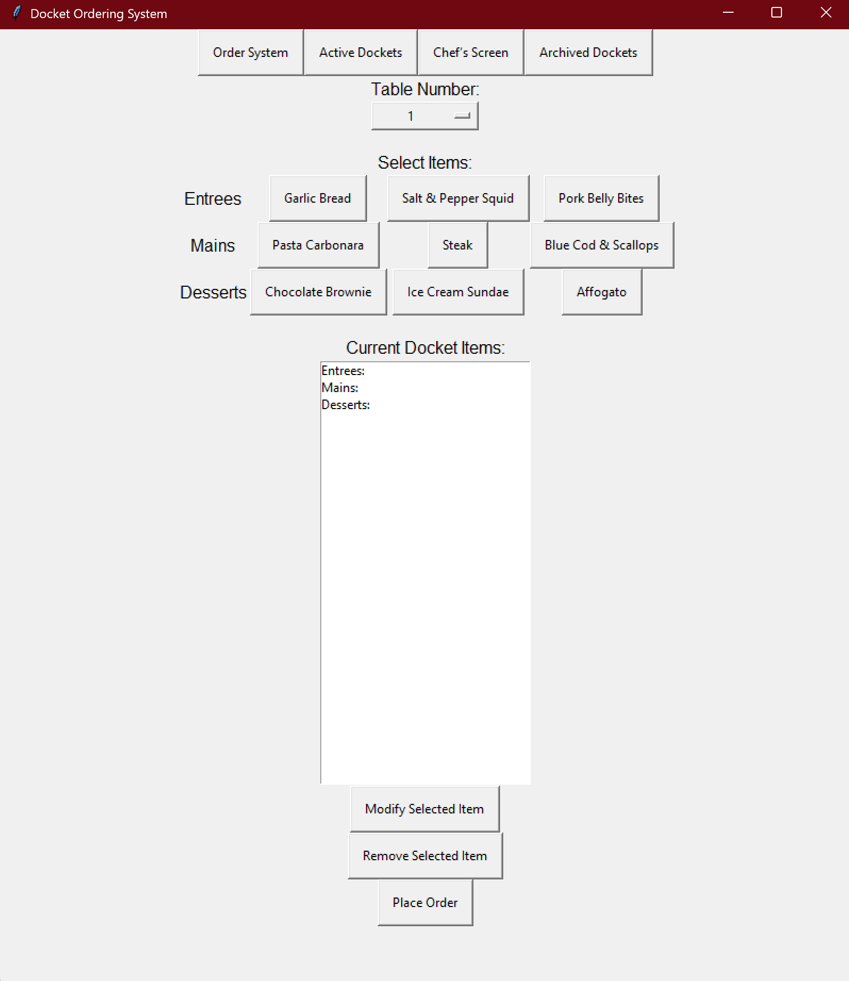
Image xx: The “Order System” screen of my application. The series of buttons along the top were originally there to simulate different screens throughout the restaurant, however only the “Order System” portion of the application has been developed.
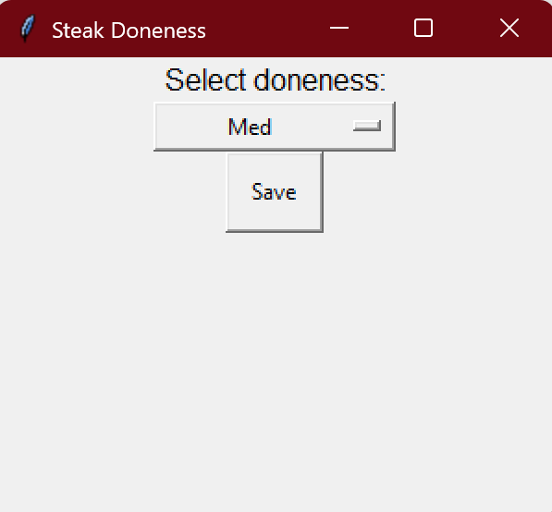
Image xx: When a user selects a steak as an order item, this screen appears requesting done-ness of the steak. Medium is the pre-set however other can be selected by clicking the drop down box.
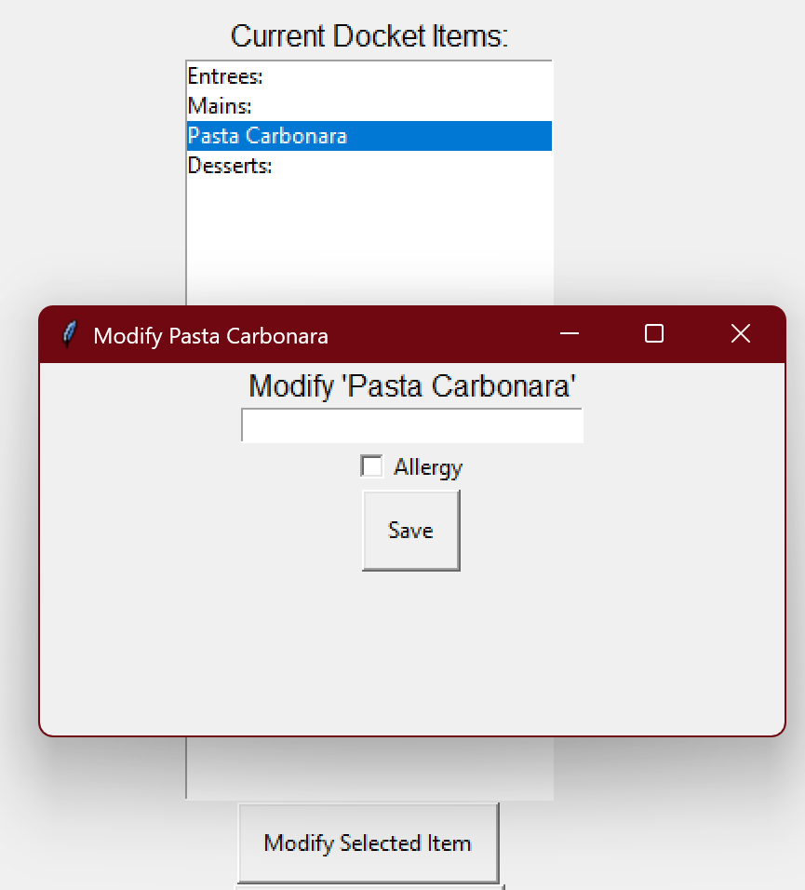
Figure xx: If a user selects a menu item and presses the “modify” button, this screen appears and the user can enter modifications to that order item e.g. no onions. The user can then select whether the modification is for an allergy.
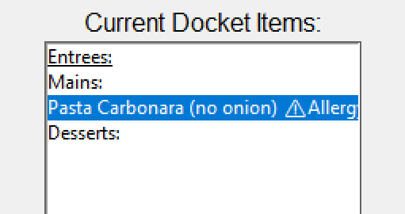
Figure xx: An example of a modified item. The user has ticket the allergy box, and so the modification has been marked with an allergy warning.

9.6 ERD
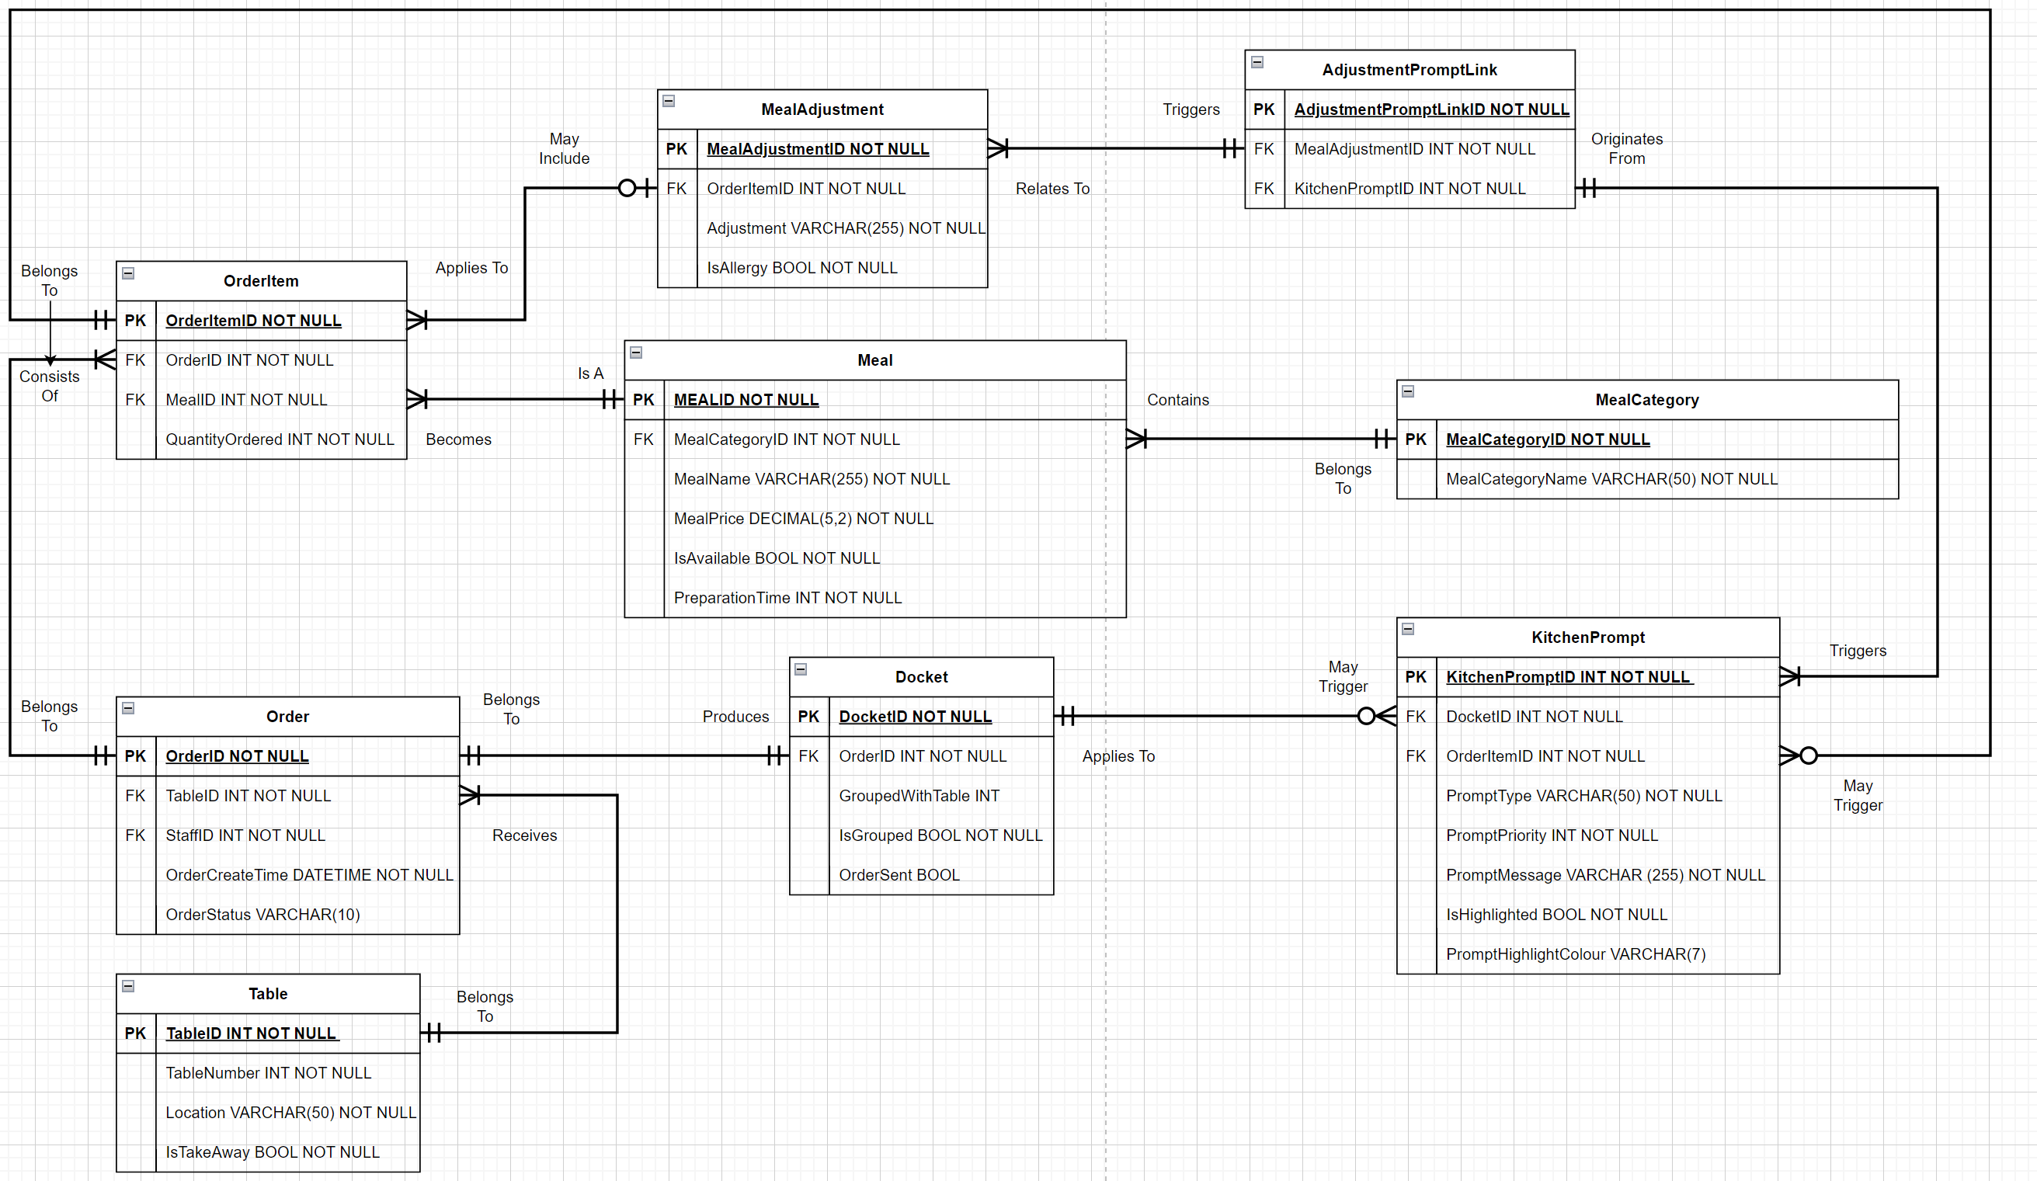
Figure xx: The ERD I have created to base my database on.

9.7 Data Dictionary
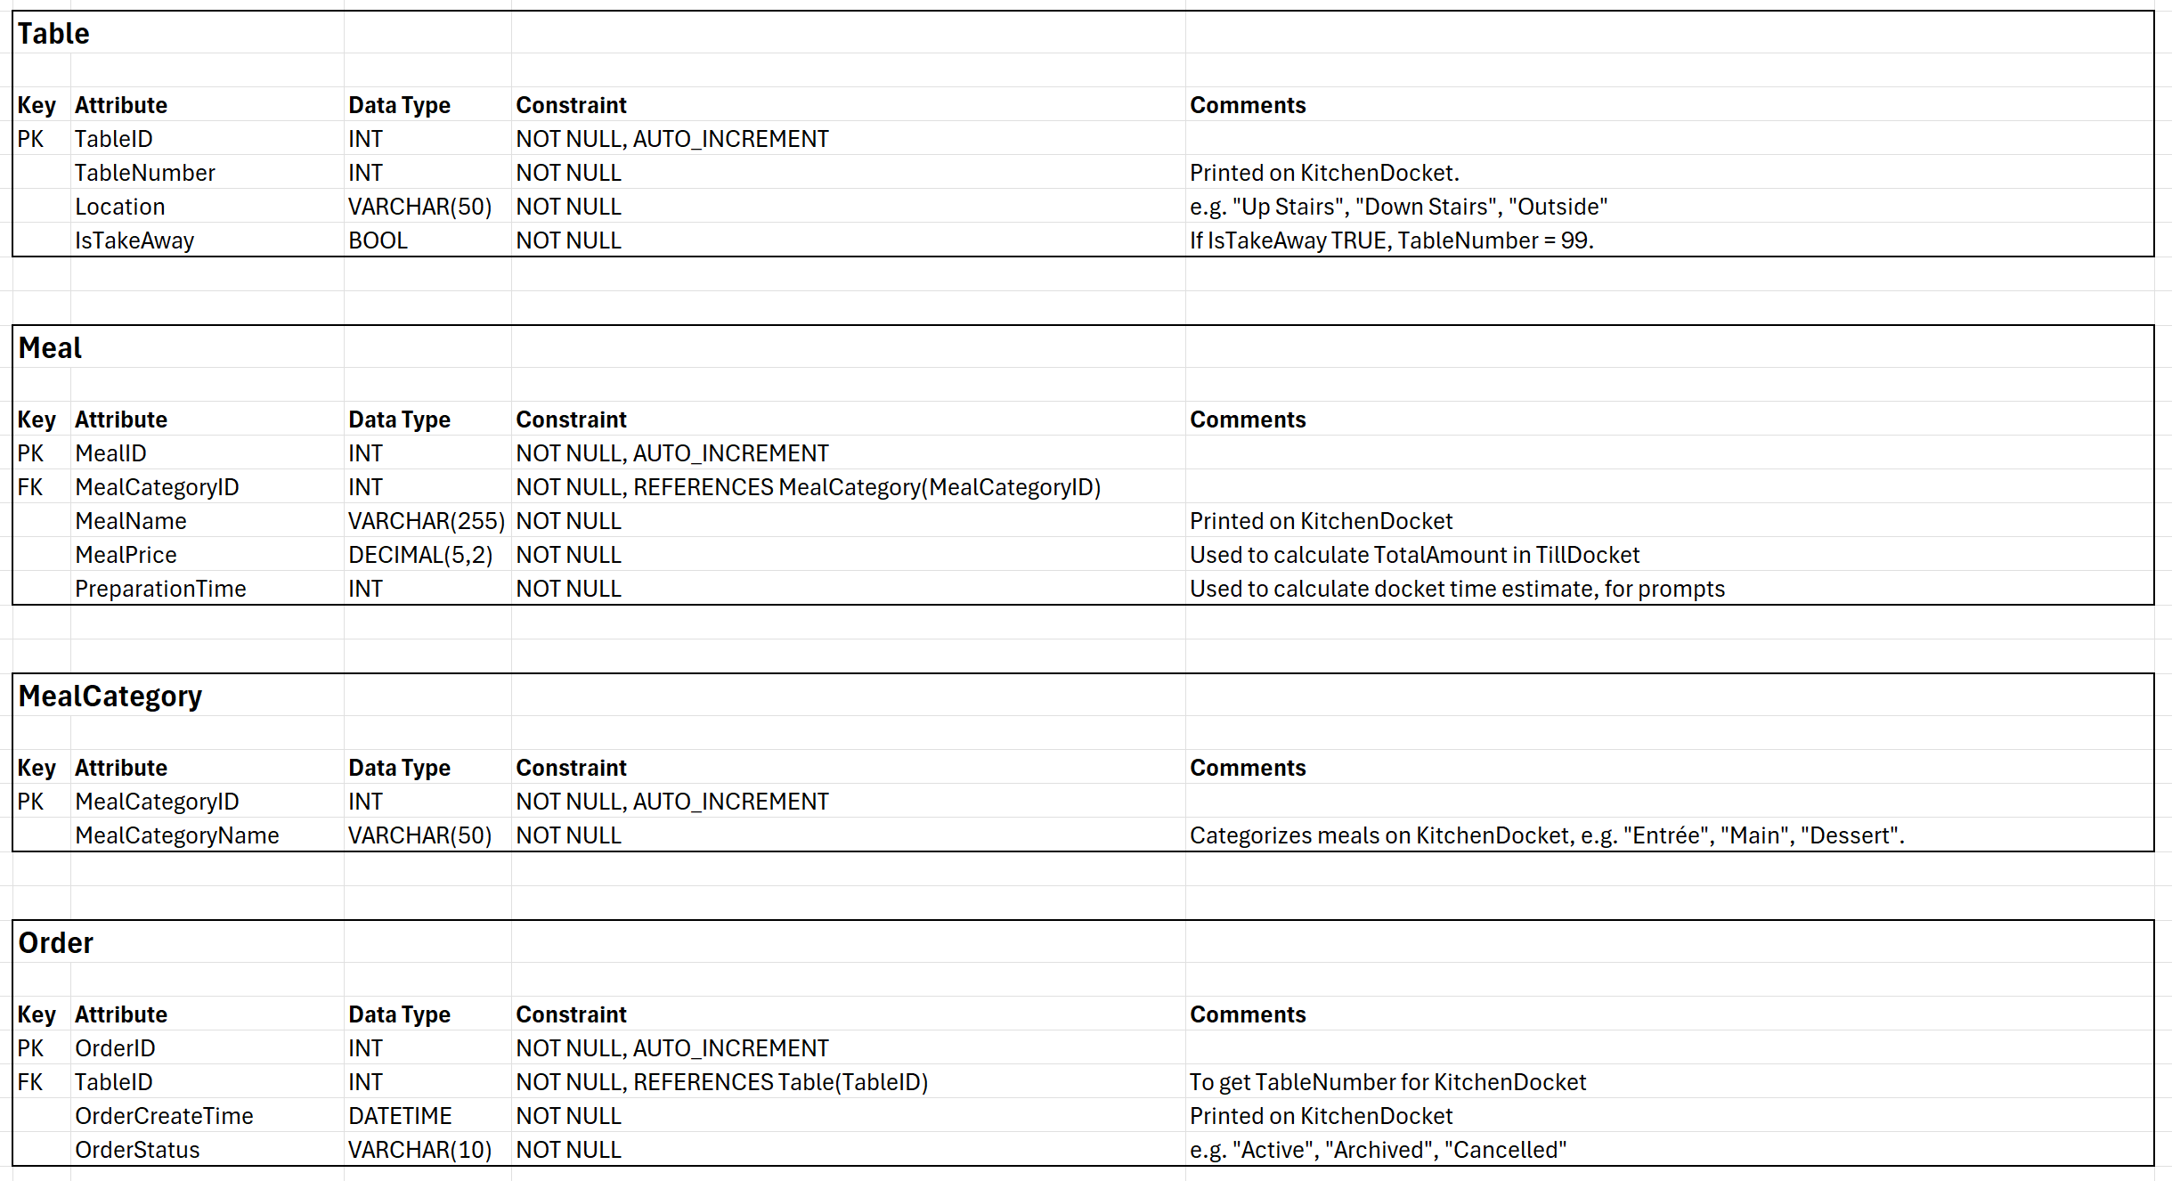
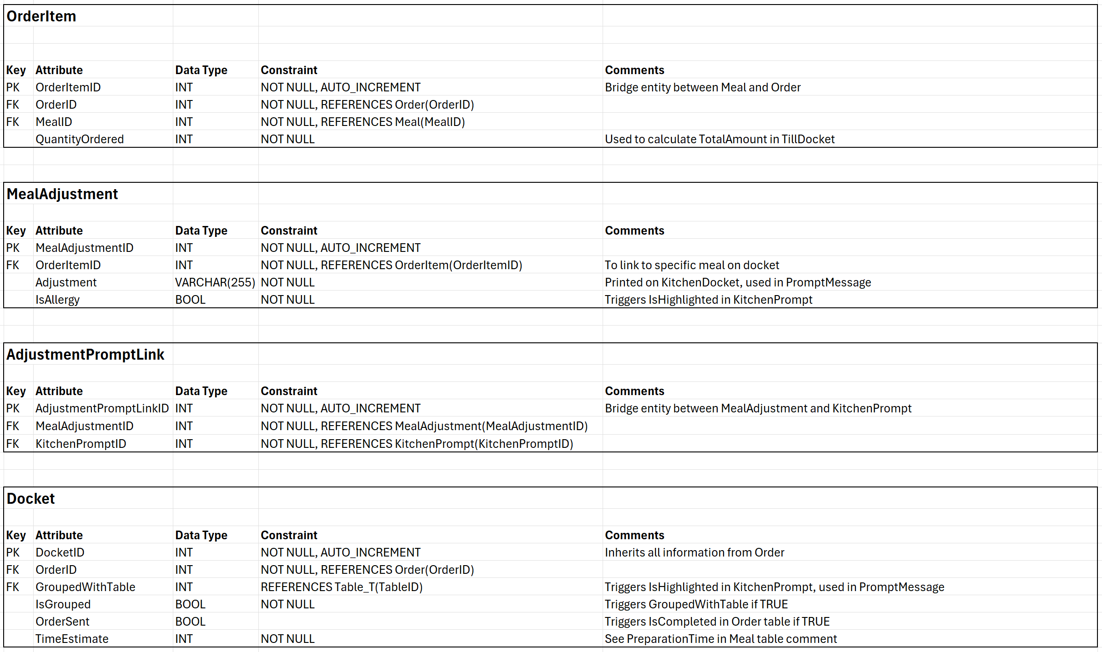
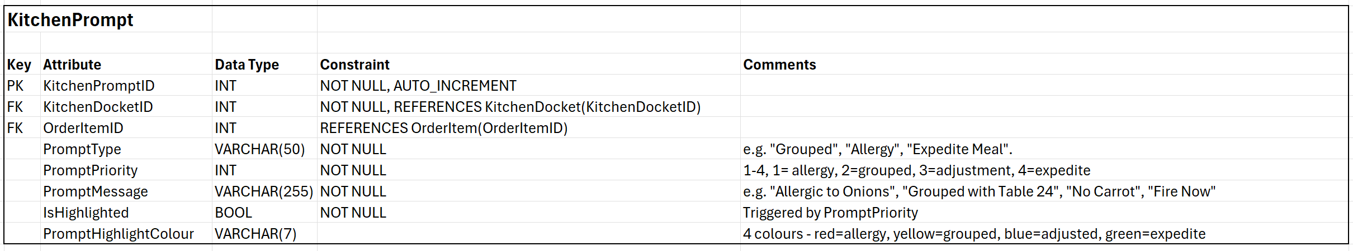
Figure xx – xx: Screenshots of the data dictionary I have created, based on my ERD.

9.8 Images of created Database
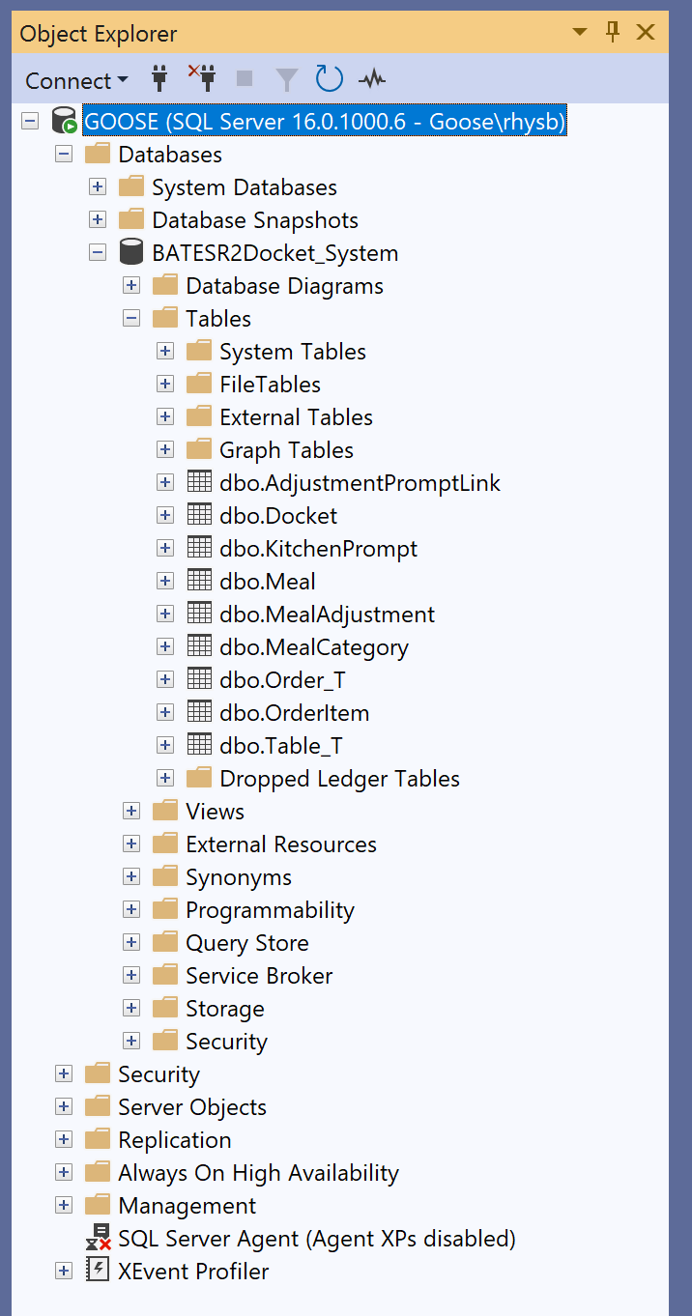
Figure xx: A screenshot of my created database, with my tables
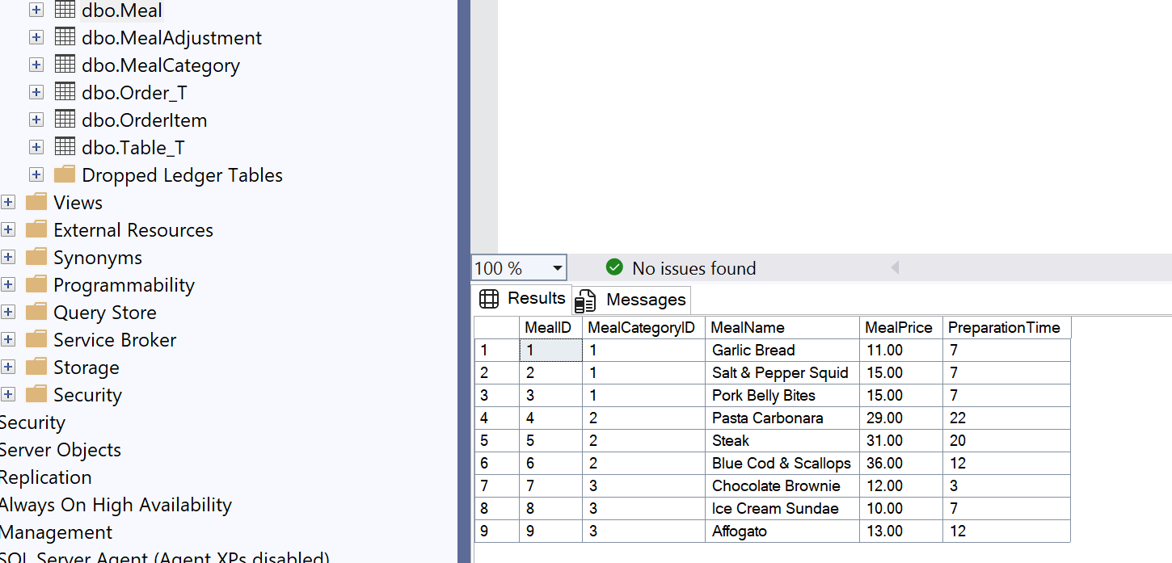
Figure xx: Example table contents, in this case for the “Meal” table which contains the meals that can be ordered in my application.

9.9 Database creation
Please use the following link to access the SQL code required to create my database

https://github.com/Rhoose-M8/Digital-Docket-System/tree/main/BATESR2%20Digital%20Docket%20System%20UNFINISHED

9.10 Python logic
Please use the following link to access the python code used in this project, including python logic and Guizero. Please note that the python logic available in this link also features several unfinished attempts at continued logic development, however was ceased after a scope change was implemented.
https://github.com/Rhoose-M8/Digital-Docket-System/tree/main/BATESR2%20Digital%20Docket%20System%20UNFINISHED

